Value of Platelet Rich Fibrin as Surgical Adjuvant in Management of Mandibular Fracture.

Abstract
Objectives: The aim of this study is to evaluate the effect of Platelet Rich Fibrin (PRF) in bone regeneration and healing in cases of fracture mandible.
Patients and Methods: Forty patients diagnosed clinically and radiographically with mandibular fracture treated with open reduction and rigid internal fixation, they were randomly divided into two groups (n=20), either Group A (Fixation with plates and screws with PRF membrane along the fracture line) or Group B (Fixation with platelet and screws only). Mean Bone Density was assessed via Computed tomography at 1week, 3 months, 6 months postoperative. The pain was assessed using numerical rating scale (NRS) during 1st, 3rd day and 1 week postoperatively, as well as maximum mouth opening.
Results: Faster bone regeneration was observed in the study group. The mean bone density was for study group at 1week, 3 months and 6 months 270.80±79.60, 575.40±83.49 and 890.10±130.55 respectively, in contrast to control group where the mean bone density was 223.00±53.53, 408.80±76.59 and 635.80±94.58 for 1 week, 3months and 6 months respectively, there was no statistically significant difference as regard pain and maximum mouth opening between both groups.
Conclusion: PRF could be considered as an adjuvant to accelerate bone healing in mandibular fractures and valid option in regenerative therapies in maxillofacial surgeries.
Keywords
Fracture Mandible, Platelet Rich Fibrin, Bone healing.

Introduction
Mandible fractures account for a significant portion of maxillofacial injuries and the evaluation, diagnosis, and management of these fractures remain challenging despite improved imaging technology and fixation techniques. Understanding appropriate surgical management can prevent complications such as malocclusion, pain, and revision procedures. Depending on the type and location of the fractures, various open and closed surgical reduction techniques can be utilized ⁽¹⁾.
The healing of hard and soft tissues is mediated by a wide range of intra and extra-cellular events that are regulated by protein signals. Elsisy et al, suggested that chitosan is very effective in bone formation⁽²⁾. Also, It is known that platelets are involved in the process of healing through blood clot formation and release of growth factors that promote and maintain healing ⁽³⁾, therefore one of the great challenges of clinical research has been the development of bioactive surgical additives, which help to regulate inflammation and increase the speed of healing process ⁽⁴⁾.
Platelet-rich fibrin (PRF) is a second-generation platelet concentrate developed by ⁽⁵⁾ PRF contains platelets, leukocytes, cytokines and adhesive proteins. The presence of white blood cells (WBCs), that secrete a large quantity of growth factors ⁽⁵⁾. PRF is simpler and less expensive to prepare, as well as being less risky to the patients. Owing to its dense fibrin matrix, PRF takes longer to be resorbed by the host, which results in slower and sustained release of platelet and leukocyte derived growth factors in to the wound area ^{(6,7)}
Several methods are available for the assessment of bone healing including densitometry, direct digital radiography, and bone biopsy. Computed tomography (CT) is an imaging modality that is being is widely used for maxillofacial imaging, as it provides accurate two and three-dimensional radiographic images of an anatomical structure with an increased precision, lower doses of radiation, and lower costs ⁽⁸⁾. Assessment of bone union after a fracture is an important clinical consideration. Wrong assessment of bone healing can have major negative consequences for a patient. Especially if bone union is doubtful, an objective and accurate assessment tool can be helpful in clinical decision making ⁽⁹⁾.
PRF showed promising effect on bone regeneration either alone or combined with other osteogenic materials. Recent studies reported that PRF showed safe and promising results, without contradictory findings, and showed several advantages and possible indications for PRF to be used ⁽¹⁰⁾.

Subjects and Methods
This study was designed as a prospective comparative study where patients were selected from the Emergency Room of Benha University Hospital and from the Outpatient Clinic of Oral and Maxillofacial Surgery, Otorhinolaryngology department Benha University from January 2020 to January 2022.
Patient Selection
A sample of 40 patients with mandibular fracture were enrolled in the study to evaluate the difference in bone density in the fracture treated with conventional plates and screws with PRF to that treated with conventional plates and screws only.
The study was approved by the medical ethical committee of Benha Faculty of medicine and written informed consent from the patients were obtained after detailed explanation of all the procedures. Each participant diagnosed with mandibular fracture, patients divided into two groups, each with 20 patients:
Group A (Study Group): The mandibular fracture was treated by open reduction and direct fixation using the conventional 2.0 mm miniplates and screws with placement of PRF membrane.
Group B (Control Group): The mandibular fracture was treated by open reduction and direct fixation using the conventional 2.0 mm miniplates and screws.
Standardized preoperative panoramic radiographs and CT scans axial, coronal and 3D reconstruction views to assess the number and location of line or lines of fracture, localize the inferior alveolar canal and any teeth in the fracture line. Patients were admitted to the hospital and routine laboratory investigations were performed before surgery, ECG, and chest radiograph for patients older than 40 years of age.
Preparation of Platelet rich fibrin (PRF)
Twenty milliliters of patient’s whole venous blood were collected in 2 sterile 10 ml glass test tubes without anticoagulant. Then the test tubes were placed in a table centrifuge machine at 3000 rotations per minute (rpm) for 10 minutes. The resultant product consisted of the following three layers: the top-most layer consisting of acellular platelet poor plasma (PPP), platelet rich fibrin layer (PRF) in the middle and red blood cells (RBCs) at the bottom. The PRF was then separated from PPP and RBC layer. Dental PRF box device developed for PRF membrane preparation to secure the PRF and to drain the excess fluid when compressed (Fig. 1).
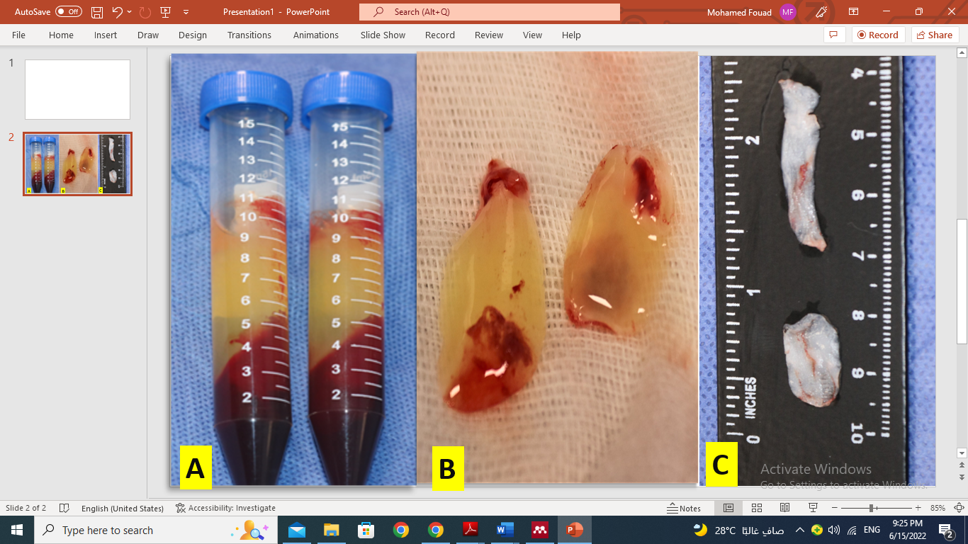
Fig. (1): steps of PRF preparation, A) after centrifugation and separation into 3 layers, B) PRF membrane, C) after compression in dental PRF box.

Operative procedures
All procedures were performed under general anesthesia and strict aseptic conditions. The oral cavity was first disinfected with povidone-iodine, as well as extra-orally. Intermaxillary fixation (IMF) was used temporarily to adjust the occlusion. After exposing all the fracture lines through an intraoral incision, the fractures were mobilized, and any soft tissue entrapped within the fracture lines were removed, and the bone reduction was done.
Fixation of the fractures was done as follows: (Study Group A) as in (Fig. 2 A): The fracture was treated by reduction and fixation using conventional 2.0 mm miniplates and screws with placement of PRF membrane. (Control Group): as in (Fig. 2 B): The fracture was treated by reduction and fixation using conventional 2.0 mm miniplates and screws.
After checking the correct reduction of the fracture and the stability of the internal fixation, the IMF was removed and the wound was closed in layers using polyglycolic polylactic 3-0 suture material (Vicryl, Ethicon, Cornelia, GA, USA).
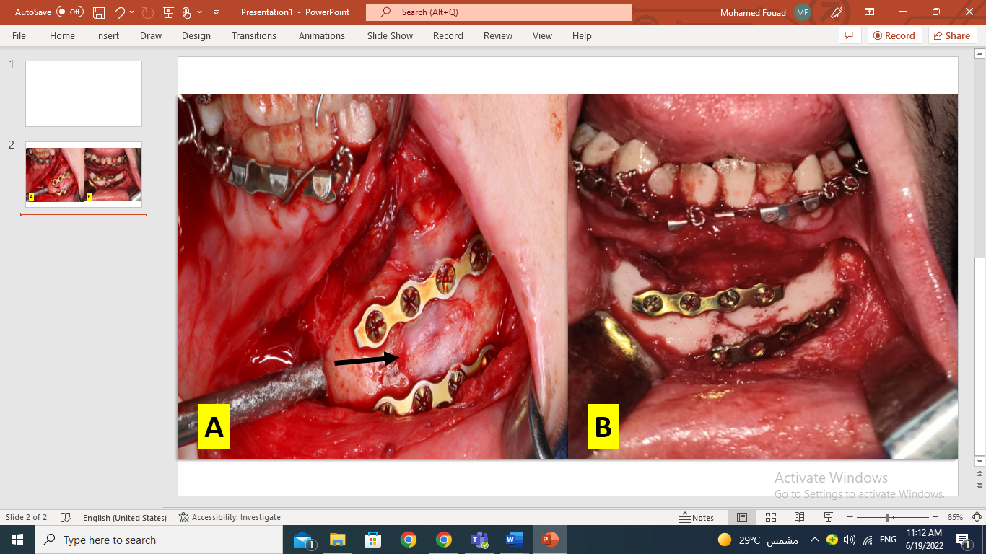
Fig. (2): A) Study case showing fixation of fracture using miniplates and screws with PRF membrane (black arrow) overlying the fracture line. B) Control case showing Fixation of fracture using miniplates and screws.
Computed tomography (CT) was performed immediately postoperative, at 3 months and at 6 months consequently to evaluate the adequacy of the reduction of the fractured segment, the progress of the healing process and measurement of the mean bone density at the site of the fracture line by using 3 points at each region of interest [ROI], these 3 points distributed inside the fracture line then taking their mean value to determine the mean bone density (Fig.3). The pain was assessed using numerical rating scale (NRS) during 1st, 3rd day and 1 week postoperatively, as well as maximum mouth opening.

Statistical analysis
The data were recorded on an “Investigation report form”. These data were tabulated, coded then analyzed using the computer program SPSS (Statistical package for social science) version 26. Descriptive statistics were calculated for the data in the form of Mean and Standard deviation (±SD) or Number and percent. In the statistical comparison between the different groups, the significance of difference was tested using Student's t-test to compare between mean of two groups of numerical (parametric) data, for continuous non- parametric data, Mann-Whitney U- test was used for inter-group analysis, ANOVA test to compare between more than two groups of numerical (parametric) data, for continuous non- parametric data, Friedman test was used, post-hoc analysis was used for in between group analysis. Inter-group comparison of categorical data was performed by using chi square test (X2-value). P value <0.05 was considered statistically significant (S) in all analyses.

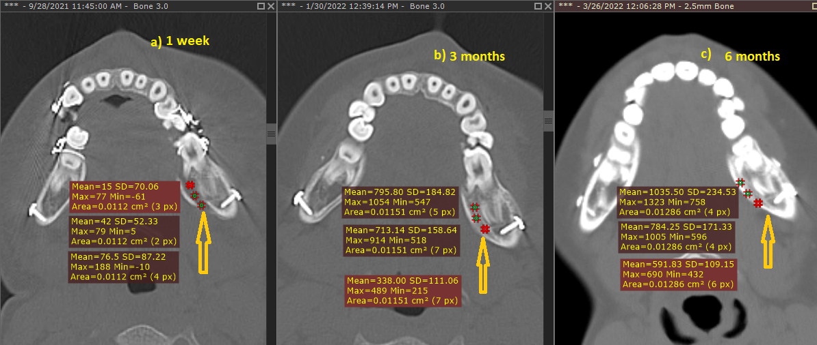
Fig. (3): 3 points are taken along ROI on left angle of mandible, a) Evidence of linear fracture line along the left mandibular angle, b) reaction denoting progress of bone healing with decreased bone gap at fracture line, c) Increased bone density with barely perceived fracture line.
Results
In the present study, there was 35 males and 5 females, age ranging from 18 to 50 years were included with a mean of 25.8±8.3. The main cause of mandibular fracture was road traffic accident in 25 patients. while 8 patients were due to fall from a height and 7 patients due to violence. Results showed he mean bone density was for study group at 1week, 3 months and 6 months 270.80±79.60, 575.40±83.49 and 890.10±130.55 respectively, in contrast to control group where the mean bone density was 223.00±53.53, 408.80±76.59 and 635.80±94.58 for 1 week, 3months and 6 months respectively, the difference between both groups was found to be statistically significant (table,1). Also, there was observable significant increase in bone density for 3 months and 6 months follow up period compared to 1 week in both groups.

Table (1): Comparison between the two studied groups according to bone density.
 | Group A (n=20) |  | Group B (n=20) |  | Test of sig. | p-value
 | Mean | S. D | Mean | S. D
1 week | 270.80 | 79.60 | 223.00 | 53.53 | 2.2 | 0.02*
3 months | 575.40 | 83.49 | 408.80 | 76.59 | 6.6 | <0.001*
6 Months | 890.10 | 130.55 | 635.80 | 94.58 | 7.1 | <0.001*
Indicate significance at p ≤ 0.05

Results showed observable significant decrease in NRS pain scores during Day 3 and 1 week compared to Day 1 NRS scores in each group, while There was no statistically significant difference in pain level between both groups in the NRS scores (fig. 4) at the different observation times. For mouth opening in both groups, there was improving overall follow up periods (3rd day ,1 week, first month and 6 months post operatively) and it was statistically significant for all. while not significant between both groups at each follow up periods (fig. 5). In both groups, edema was limited to the area of operation and resolved completely in all cases by the end of 2-3rd week postoperatively and no infection nor wound dehiscence were detected.

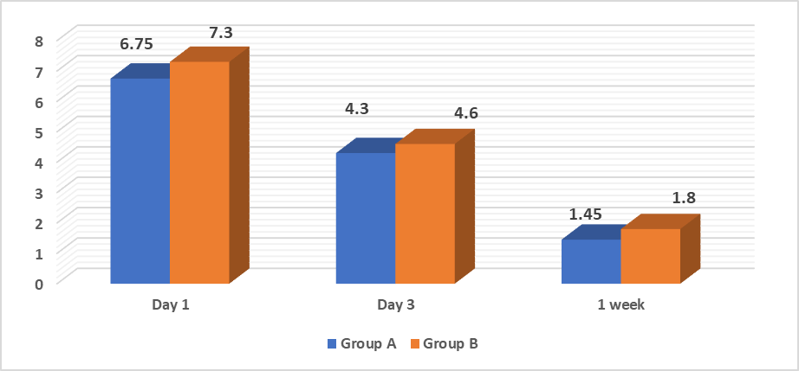
Fig. (4): Group A and Group B regarding Post-operative NRS pain score assessment.

Fig. (5): Group A and Group B regarding Post-operative maximum mouth opening.

Discussion
In this study, 87.5% of the patients were males while 12.5% were females which indicated that the male ratio was higher than female. This result was supported by ⁽¹¹⁾ , they reported that 78% of patients were male and 22% were female. Also ⁽¹²⁾ reported that males represent 88% of cases.. Road traffic accidents were found to be the most frequent cause of fractures accounting for 62.5% of the cases, followed by falls 20.0% then violent assaults 17.5%, which was in agreement with ⁽¹²⁾ ⁽¹³⁾. This may be attributed to the fact that the females drive vehicles less frequently and more carefully than males. Also, due to reckless driving and badly paved routes, bad condition of the vehicles and the insufficient use of seat belts in the developing countries.
Using PRF instead of PRP in our study coincides with another two studies in which the effect of PRP and platelet-enriched fibrin on bone formation in bone tissue engineering was compared. The results indicated that the osteogenic characteristics of platelet-enriched fibrin are superior to those of PRP in bone tissue engineering ⁽¹⁴⁾, ⁽¹⁵⁾. However, this finding was not in agreement with an in-vitro human cell culture study that aimed to examine the growth factors release from PRP and PRF. They showed that PRP application in cell cultures leads to higher levels of growth factors than PRF application ⁽¹⁶⁾. The difference from other results may be because most of PRF growth factors were embedded in the clot and gradually released and exerted a stronger and more durable effect than PRP which provides a sudden release of growth factors after which the concentrations of growth factor fall.
The present study showed that the mean bone density in the study group was higher than the control group. This finding proved to be statistically significant throughout the follow up period. A lot of studies support the PRF as a healing biomaterial because the high levels of growth factors in the PRF which accelerates the proliferation of osteoprogenitor cells. Moreover, the fibrin seems to be a relevant matrix to support osteoblastic growth and differentiation, that is why it is used frequently during bone tissue-engineering experimentations ⁽¹⁷⁾.
Our result was in agreement with ⁽¹⁸⁾, they conducted a split- mouth clinical trial where 12 patients were suffering from bilateral mandibular fractures were included. they found that PRF application on the fracture line was helpful in improvement and acceleration of the fracture healing. ⁽¹⁹⁾ also conducted a split-mouth study to evaluate osseous regeneration in extraction sockets with and without platelet-rich fibrin to assess its effects on bone cells and soft tissue response. They concluded that platelet-rich fibrin improves healing of both soft and hard tissues. Although osseous healing did not differ significantly between the groups. Also, ⁽¹⁵⁾ conducted a study to evaluate the validity of application of the platelet-rich fibrin versus platelet-rich plasma on the outcome of the mandibular fracture. They concluded that PRP and PRF seem to aid acceleration of bone healing in mandibular fractures, but PRF more efficient than PRP in bone formation.
Regarding the postoperative pain, it was assessed using a Numeric Rating Scale (NRS), there was no significant difference between the results of post operative pain during 1st, 3rd day and 1 week in the two groups. Our results came in agree with ⁽¹⁸⁾ and ⁽²⁰⁾. In contrast to ⁽²¹⁾, they assessed the effect of PRF on postoperative pain in mandibular third molar extraction sockets and found that the application of PRF decreased the severity of immediate post-operative pain and inflammation. The difference between our study and this one may be because of the fact that the type of incision could affect the degree of wound healing and in consequence the degree of pain.
In this study, the postoperative mouth opening measurements showed a significant difference in some periods and it was obviously decreased on the 2nd day postoperatively due to the pain related to the fracture and due to the spasm of the muscles of mastication. The mouth opening increased significantly with time, but there was no statistically significant difference between both PRF study group and control group which was in agreement with ⁽¹⁸⁾, ⁽²⁰⁾. In contrast to ⁽²¹⁾, they assessed the effect of PRF on post-operative trismus after mandibular third molar extraction sockets, on the first post-operative day, it was 33.00±1.59 in the Case group and 31.07±3.19 mm in the Control group and this difference between the two groups was statistically significant indicating that the use of PRF influenced the degree of restriction of mouth opening, but it was another procedure different than our study.
Conclusion
PRF application on the fracture line in the mandible may be helpful in improvement of the fracture healing.
Conflict of interest
The authors declare that they have no conflicts of interest.
References
1. Pickrell BB, Hollier LH. Evidence-Based Medicine: Mandible Fractures. Plast Reconstr Surg. 2017;140(1):192-200.
2. Elsisy M, Elhamshary A, Haroon YM, Sallam S. Effect of chitosan on bone restoration in nasal bone defect: An experimental study. Egypt J Otolaryngol. 2014;30(2):94-101.
3. Lauritano D, Avantaggiato A, Candotto V, Zollino I, Carinci F. Is platelet-rich fibrin really useful in oral and maxillofacial surgery? Lights and shadows of this new technique. Ann Oral Maxillofac Surg. 2013;1(3):1-5.
4. Dohan, D. M., Choukroun, J., Diss, A., Dohan, S. L., Dohan, A. J. J., Mouhyi, J., & Gogly, B. (2006a). Platelet-rich fibrin (PRF): a second-generation platelet concentrate. Part I: technological concepts and evolution. Oral surgery, oral medicine, oral pathology, oral radiology, and endodontics, 101(3), 37-44.
5. Dohan, D. M., Choukroun, J., Diss, A., Dohan, S. L., Dohan, A. J. J., Mouhyi, J., & Gogly, B. (2006d). Platelet-rich fibrin (PRF): a second-generation platelet concentrate. Part IV: clinical effects on tissue healing. Oral surgery, oral medicine, oral pathology, oral radiology, and endodontics, 101(3), 56-60.
6. Dohan, D. M., Choukroun, J., Diss, A., Dohan, S. L., Dohan, A. J. J., Mouhyi, J., & Gogly, B. (2006b). Platelet-rich fibrin (PRF): a second-generation platelet concentrate. Part II: platelet-related biologic features. Oral surgery, oral medicine, oral pathology, oral radiology, and endodontics, 101(3), 45-50.
7. Dohan, D. M., Choukroun, J., Diss, A., Dohan, S. L., Dohan, A. J. J., Mouhyi, J., & Gogly, B. (2006c). Platelet-rich fibrin (PRF): a second-generation platelet concentrate. Part III: leucocyte activation: a new feature for platelet concentrates?. Oral surgery, oral medicine, oral pathology, oral radiology, and endodontics,101(3), 51-55.
8. Daif ET. Effect of autologous platelet-rich plasma on bone regeneration in mandibular fractures. Dent Traumatol. 2013;29(5):399-403.
9. Willems A, Iҫli C, Waarsing JH, Bierma-Zeinstra SMA, Meuffels DE. Bone Union Assessment with Computed Tomography (CT) and Statistical Associations with Mechanical or Histological Testing: A Systematic Review of Animal Studies. Calcif Tissue Int. 2022;110(2):147-161.
10. Raafat NS and AI. The Effect of Platelet-Rich Fibrin on Bone Defects Repair in Experimental Animals: A Mini-Review. Austin Thromb reasearch Treat. 2019;3(1):1-3.
11. Czerwinski M, Parker WL, Chehade A, Williams HB. Identification of mandibular fracture epidemiology in Canada: Enhancing injury prevention and patient evaluation. Can J Plast Surg. 2008;16(1):36-40.
12. El Shehaby DM, Farahat AMA, Shahine MS, Mohammed HM. Medico-legal evaluation and trend of the different patterns of maxillofacial fractures concomitant with closed head injury in Upper Egypt: retrospective study. Egypt J Forensic Sci. 2020;10(1):11.
13. Chen Y-T, Chiu Y-W, Chang Y-C, Lin C-W. Ten-year retrospective study on mandibular fractures in central Taiwan. J Int Med Res. 2020;48(7):1-8.
14. Zhu S-J, Choi B-H, Jung J-H, et al. A comparative histologic analysis of tissue-engineered bone using platelet-rich plasma and platelet-enriched fibrin glue. Oral Surgery, Oral Med Oral Pathol Oral Radiol Endodontology. 2006;102(2):175-179.
15. Al-Khawlani E, Adly O, Hamed T, Abass A, Abdelmabood A. Clinical and radiographic evaluation of platelet-rich fibrin gel on the outcome of mandibular fracture. Egypt J Oral Maxillofac surg. 2014;5(3):77-83.
16. Gaßling VLW, Açil Y, Springer IN, Hubert N, Wiltfang J. Platelet-rich Plasma and Platelet-rich fibrin in human cell culture. Oral Surgery, Oral Med Oral Pathol Oral Radiol Endodontology. 2009;108(1):48-55.
17. Al-Hamed FS, Mahri M, Al-Waeli H, Torres J, Badran Z, Tamimi F. Regenerative Effect of Platelet Concentrates in Oral and Craniofacial Regeneration. Front Cardiovasc Med. 2019;6(1), 126-140.
18. Al Rayess AM, El Dibany MM, Melek LN. Clinical and radiographic study of healing of mandibular fractures using plasma rich fibrin membrane with miniplate fixation. Alexandria Dent J. 2018;43(1):41-47.
19. Kumar YR, Mohanty S, Verma M, et al. Platelet-rich fibrin: The benefits. Br J Oral Maxillofac Surg. 2015;54(1):57-61.
20. Esen, A., Menziletoğlu, D., & Işık, B. K. (2016). Effect of platelet-rich fibrin in reducing postoperative complications after impacted third molar surgery: a prospective, randomized controlled clinical trial. Acta Odontologica Turcica, 34(2), 46-48.
21. Kumar N, Prasad K, Ramanujam L, K R, Dexith J, Chauhan A. Evaluation of Treatment Outcome After Impacted Mandibular Third Molar Surgery With the Use of Autologous Platelet-Rich Fibrin: A Randomized Controlled Clinical Study. J Oral Maxillofac Surg. 2015;73(6):1042-1049.

